1. [<!--...-->](http://www.w3schools.com/TAGs/tag_comment.asp)🡺 Comment
2. [<!DOCTYPE>](http://www.w3schools.com/TAGs/tag_doctype.asp) 🡺Defines the document type
3. [<a>](http://www.w3schools.com/TAGs/tag_a.asp)🡺Defines a hyperlink
4. [<audio>](http://www.w3schools.com/TAGs/tag_audio.asp)🡺Defines sound content
5. [<b>](http://www.w3schools.com/TAGs/tag_b.asp)🡺Defines bold text
6. [<bdo>](http://www.w3schools.com/TAGs/tag_bdo.asp)
7. [<body>](http://www.w3schools.com/TAGs/tag_body.asp)🡺Defines the document's body
8. [<br>](http://www.w3schools.com/TAGs/tag_br.asp)🡺Defines a single line break
9. [<button>](http://www.w3schools.com/TAGs/tag_button.asp)🡺Defines a clickable button

[<caption>](http://www.w3schools.com/TAGs/tag_caption.asp)🡺Defines a table caption

[<center>](http://www.w3schools.com/TAGs/tag_center.asp)🡺Not supported in HTML5. Use CSS instead.Defines centered text

[<code>](http://www.w3schools.com/TAGs/tag_code.asp)🡺Defines a piece of computer code

[<datalist>](http://www.w3schools.com/TAGs/tag_datalist.asp)🡺Specifies a list of pre-defined options for input controls

<dl>🡺description list. Has 2 elements <dt> and <dd> 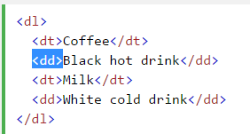

[<del>](http://www.w3schools.com/TAGs/tag_del.asp)🡺Defines text that has been deleted from a document

<dir>🡺Not supported in HTML5. Use <ul> instead.Defines a directory list

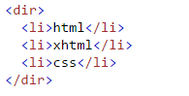

[<div>](http://www.w3schools.com/TAGs/tag_div.asp)🡺Defines a section in a document

[<span>](http://www.w3schools.com/TAGs/tag_span.asp)🡺Defines a section in a document

[<em>](http://www.w3schools.com/TAGs/tag_em.asp)🡺Defines emphasized text

[<form>](http://www.w3schools.com/TAGs/tag_form.asp)🡺Defines an HTML form for user input

[<h1> to <h6>](http://www.w3schools.com/TAGs/tag_hn.asp)🡺Defines HTML headings

[<head>](http://www.w3schools.com/TAGs/tag_head.asp)🡺Defines information about the document

[<hr>](http://www.w3schools.com/TAGs/tag_hr.asp)

[<html>](http://www.w3schools.com/TAGs/tag_html.asp)

[<i>](http://www.w3schools.com/TAGs/tag_i.asp)

[<img>](http://www.w3schools.com/TAGs/tag_img.asp)

[<input>](http://www.w3schools.com/TAGs/tag_input.asp)

[<kbd>](http://www.w3schools.com/TAGs/tag_kbd.asp)🡺Defines keyboard input

[<pre>](http://www.w3schools.com/TAGs/tag_pre.asp)🡺Defines preformatted text

[<label>](http://www.w3schools.com/TAGs/tag_label.asp)🡺Defines a label for an <input> element

<ul>

<ol>

<[<li>](http://www.w3schools.com/TAGs/tag_li.asp)

[<link>](http://www.w3schools.com/TAGs/tag_link.asp)🡺 To link to an external style sheet, use the [<link>](http://www.w3schools.com/tags/tag_link.asp) tag

[<mark>](http://www.w3schools.com/TAGs/tag_mark.asp)🡺Defines marked/highlighted text

[<meta>](http://www.w3schools.com/TAGs/tag_meta.asp)🡺Defines metadata about an HTML document

[<noscript>](http://www.w3schools.com/TAGs/tag_noscript.asp)🡺Defines an alternate content for users that do not support

[<script>](http://www.w3schools.com/TAGs/tag_script.asp)🡺Defines a client-side scripts

<select>

[<option>](http://www.w3schools.com/TAGs/tag_option.asp)🡺Defines an option in a drop-down list

[<p>](http://www.w3schools.com/TAGs/tag_p.asp)

[<small>](http://www.w3schools.com/TAGs/tag_small.asp)🡺Defines smaller text

[<sub>](http://www.w3schools.com/TAGs/tag_sub.asp)🡺

[<sup>](http://www.w3schools.com/TAGs/tag_sup.asp)

<ins>

<del>

[<u>](http://www.w3schools.com/TAGs/tag_u.asp)

<B>

[<video>](http://www.w3schools.com/TAGs/tag_video.asp)🡺Defines a video or movie

[<table>](http://www.w3schools.com/TAGs/tag_table.asp)

[**<thead>**](http://www.w3schools.com/TAGs/tag_thead.asp)

[**<tbody>**](http://www.w3schools.com/TAGs/tag_tbody.asp)

[<tr>](http://www.w3schools.com/TAGs/tag_tr.asp)

[<th>](http://www.w3schools.com/TAGs/tag_th.asp)

[<td>](http://www.w3schools.com/TAGs/tag_td.asp)

[<textarea>](http://www.w3schools.com/TAGs/tag_textarea.asp)

[<strong>](http://www.w3schools.com/TAGs/tag_strong.asp)

[<style>](http://www.w3schools.com/TAGs/tag_style.asp)

**List of the Global Attributes:**

1. [class](http://www.w3schools.com/tags/att_global_class.asp) 🡺can come an any element 🡺ms
2. [dir](http://www.w3schools.com/tags/att_global_dir.asp)🡺used in <DBO> possible values are ‘rtl ‘and’ ltr’
3. [hidden](http://www.w3schools.com/tags/att_global_hidden.asp)🡺
4. [id](http://www.w3schools.com/tags/att_global_id.asp)
5. [style](http://www.w3schools.com/tags/att_global_style.asp)
6. [title](http://www.w3schools.com/tags/att_global_title.asp)

**List of HTML Event Attributes**

## Window Event Attributes

1. [onafterprint](http://www.w3schools.com/tags/ev_onafterprint.asp) 🡺Script to be run after the document is printed
2. [onbeforeprint](http://www.w3schools.com/tags/ev_onbeforeprint.asp)🡺Script to be run before the document is printed
3. [onbeforeunload](http://www.w3schools.com/tags/ev_onbeforeunload.asp)🡺Script to be run when the document is about to be unloaded
4. Onerror🡺Script to be run when an error occurs
5. [onload](http://www.w3schools.com/tags/ev_onload.asp)🡺Fires after the page is finished loading

## Form Events

1. [onblur](http://www.w3schools.com/tags/ev_onblur.asp)🡺Fires the moment that the element loses focus
2. [onchange](http://www.w3schools.com/tags/ev_onchange.asp)🡺Fires the moment when the value of the element is changed
3. [onfocus](http://www.w3schools.com/tags/ev_onfocus.asp)🡺Fires the moment when the element gets focus
4. [oninput](http://www.w3schools.com/tags/ev_oninput.asp)🡺Script to be run when an element gets user input
5. [oninvalid](http://www.w3schools.com/tags/ev_oninvalid.asp)🡺Script to be run when an element is invalid

**Example:** for invalid is when we don’t enter any text in the text box and click on a button to get submitted

1. [onreset](http://www.w3schools.com/tags/ev_onreset.asp)🡺Fires when the Reset button in a form is clicked
2. [onsearch](http://www.w3schools.com/tags/ev_onsearch.asp)🡺Fires when the user writes something in a search field (for <input="search">)
3. [onselect](http://www.w3schools.com/tags/ev_onselect.asp)🡺Fires after some text has been selected in an element
4. [onsubmit](http://www.w3schools.com/tags/ev_onsubmit.asp)🡺Fires when a form is submitted

## Keyboard Events

1. [onkeydown](http://www.w3schools.com/tags/ev_onkeydown.asp) 🡺Fires when a user is pressing a key\
2. [onkeypress](http://www.w3schools.com/tags/ev_onkeypress.asp) 🡺Fires when a user presses a key
3. [onkeyup](http://www.w3schools.com/tags/ev_onkeyup.asp)🡺Fires when a user releases a key

## Mouse Events

1. [onclick](http://www.w3schools.com/tags/ev_onclick.asp)🡺Fires on a mouse click on the element
2. [ondblclick](http://www.w3schools.com/tags/ev_ondblclick.asp)🡺Fires on a mouse double-click on the element
3. [ondrag](http://www.w3schools.com/tags/ev_ondrag.asp)🡺Script to be run when an element is dragged
4. [ondrop](http://www.w3schools.com/tags/ev_ondrop.asp)🡺Script to be run when dragged element is being dropped
5. [**onmouseover**](http://www.w3schools.com/tags/ev_onmouseover.asp)**🡺**
6. [onmouseup](http://www.w3schools.com/tags/ev_onmouseup.asp)🡺Fires when a mouse button is released over an element.
7. [onmousedown](http://www.w3schools.com/tags/ev_onmousedown.asp)🡺Fires when a mouse button is pressed down on an element
8. [onmouseout](http://www.w3schools.com/tags/ev_onmouseout.asp)🡺Fires when the mouse pointer moves out of an element
9. [**onmousemove**](http://www.w3schools.com/tags/ev_onmousemove.asp)🡺 Fires when the mouse pointer is moving while it is over an element.

## Clipboard Events

1. [oncopy](http://www.w3schools.com/tags/ev_oncopy.asp)🡺Fires when the user copies the content of an element
2. [oncut](http://www.w3schools.com/tags/ev_oncut.asp)🡺Fires when the user cuts the content of an element
3. [onpaste](http://www.w3schools.com/tags/ev_onpaste.asp)🡺Fires when the user pastes some content in an element.

## Body element Other attributes:🡺following attributes are not supported in html5

1. [background](http://www.w3schools.com/tags/att_body_background.asp)🡺Specifies a background image for a document
2. [bgcolor](http://www.w3schools.com/tags/att_body_bgcolor.asp)🡺Specifies the background color of a document
3. [vlink](http://www.w3schools.com/tags/att_body_vlink.asp)🡺Specifies the **color** of visited links in a document
4. Link==>Specifies the **color** of visited links in a document
5. [alink](http://www.w3schools.com/tags/att_body_alink.asp)🡺Specifies the **color** of an active link in a document

# <button>attributes:

1. [name](http://www.w3schools.com/tags/att_button_name.asp)
2. [type](http://www.w3schools.com/tags/att_button_type.asp)🡺this attribute can have the following possible vaues,
3. button
4. reset
5. submit
6. [value](http://www.w3schools.com/tags/att_button_value.asp)🡺**Specifies an initial value for the button**

**<div> attributes:🡺** tag is used to group block-elements to format them with CSS.

1. So div tag supports all the style related properties

**<Style> tag attributes:**

1. [align](http://www.w3schools.com/tags/att_p_align.asp)🡺 Specifies the alignment of the text. Possible value for this attribute is🡺left,right,center,justify
2. [bgcolor](http://www.w3schools.com/tags/att_table_bgcolor.asp)🡺Specifies the background color for a **table.**
3. [border](http://www.w3schools.com/tags/att_table_border.asp)🡺 Specifies whether or not the table is being used for layout purposes
4. [cellpadding](http://www.w3schools.com/tags/att_table_cellpadding.asp)🡺 Specifies the space between the cell wall and the cell content
5. [cellspacing](http://www.w3schools.com/tags/att_table_cellspacing.asp)🡺 Specifies the space between cells
6. [width](http://www.w3schools.com/tags/att_table_width.asp)🡺 Specifies the width
7. Color
8. text-align: center;
9. Height🡺
10. Margin🡺ms
11. font-family🡺ms
12. font-size🡺ms
13. colspan🡺ms
14. rowspan🡺ms
15. margin🡺ms
16. padding🡺ms
17. fontSize
18. display="none"
19. display='block’🡺 is used to Showing hidden HTML elements

**<option> tag attributes:**

# [value](http://www.w3schools.com/tags/att_option_value.asp)🡺 Specifies the value to be sent to a server

# [selected](http://www.w3schools.com/tags/att_option_selected.asp)🡺 Specifies that an option should be pre-selected when the page loads

# [disabled](http://www.w3schools.com/tags/att_option_disabled.asp) 🡺 Specifies that an option should be disabled

**<a> tag attributes:**

1. [href](http://www.w3schools.com/tags/att_a_href.asp)🡺 Specifies the URL of the page the link goes to
2. [target](http://www.w3schools.com/tags/att_a_target.asp)🡺 Specifies where to open the linked document. This attributes possible values🡺_blank,_parent ,_top, etc..

**<textarea> attributes:**

1. [cols](http://www.w3schools.com/tags/att_textarea_cols.asp)
2. [rows](http://www.w3schools.com/tags/att_textarea_rows.asp)
3. [required](http://www.w3schools.com/tags/att_textarea_required.asp)
4. [readonly](http://www.w3schools.com/tags/att_textarea_readonly.asp)🡺 Specifies that a text area should be read-only.
5. [name](http://www.w3schools.com/tags/att_textarea_name.asp)
6. [disabled](http://www.w3schools.com/tags/att_textarea_disabled.asp)

**<input> attributes:**

1. [align](http://www.w3schools.com/tags/att_input_align.asp)
2. [checked](http://www.w3schools.com/tags/att_input_checked.asp)🡺 Specifies that an <input> element should be pre-selected when the page loads (for type="checkbox" or type="radio")
3. [disabled](http://www.w3schools.com/tags/att_input_disabled.asp)
4. [max](http://www.w3schools.com/tags/att_input_max.asp)🡺 Specifies the maximum value for an <input> element. This attribute accepts 🡺number and/or date value
5. [min](http://www.w3schools.com/tags/att_input_min.asp) 🡺Specifies a minimum value for an <input> element. This attribute accepts 🡺number and/or date value
6. [maxlength](http://www.w3schools.com/tags/att_input_maxlength.asp) ==> Specifies the maximum number of characters allowed in an <input> element. this attribute accepts 🡺number value
7. [name](http://www.w3schools.com/tags/att_input_name.asp)🡺
8. [readonly](http://www.w3schools.com/tags/att_input_readonly.asp)
9. [required](http://www.w3schools.com/tags/att_input_required.asp)
10. [value](http://www.w3schools.com/tags/att_input_value.asp)🡺Purpose needed clear understanding
11. [type](http://www.w3schools.com/tags/att_input_type.asp)🡺 Specifies the type <input> element to display,

this attribute accepts one of the following values,

button  
checkbox  
color  
date   
datetime   
datetime-local   
email   
file  
hidden  
image  
month   
number   
password  
radio  
range   
reset  
search  
submit  
tel  
text,time ,url,week

CSS Selectors:

1. [.*class*](http://www.w3schools.com/cssref/sel_class.asp)Name
2. [#*id*](http://www.w3schools.com/cssref/sel_id.asp)
3. [*](http://www.w3schools.com/cssref/sel_all.asp)
4. [*element*](http://www.w3schools.com/cssref/sel_element.asp)
5. [*element,element*](http://www.w3schools.com/cssref/sel_element_comma.asp)
6. div p🡺 Selects all <p> elements inside <div> elements
7. div > p🡺 Selects all <p> elements where the parent is a <div> element
8. div + p🡺 Selects all <p> elements that are **placed immediately** after <div> elements
9. p ~ ul🡺 Selects every <ul> element that are preceded by a <p> element
10. **:not(p)**🡺 Selects every element that is not a <p> element
11. [target]🡺 Selects all elements with a target attribute
12. [target=_blank]🡺 Selects all elements with target="_blank"
13. [title~=flower]🡺 Selects all elements with a title attribute **containing the word "flower"**
14. **a[href*="w3schools"]🡺** Selects every <a> element whose href attribute value contains the substring "w3schools".
15. **[lang|=en]🡺** Selects all elements with a lang attribute value **starting with** "en"
16. **a[href^="https**"]🡺 Selects every <a> element whose href attribute **value begins with** "https"
17. **a[href$=".pdf"]**🡺 Selects every <a> element whose href attribute **value ends with** ".pdf"
18. **a:active**🡺 Selects the active link
19. **a:visited**🡺 Selects all visited links
20. a:link🡺 Selects all unvisited links
21. **p::after**🡺 Insert something after the content of each <p> element.
22. **p::before**🡺 Insert something before the content of each <p> element.
23. **input: checked**🡺 Selects every checked <input> element
24. **input:disabled**🡺 Selects every disabled <input> element
25. **input:enabled**🡺 Selects every enabled <input> element
26. **p:empty**🡺 Selects every <p> element **that has no children** (**including text nodes)**
27. **p:first-child**🡺 **Selects every <p> element that is the first child of its parent**

**Example:**

<body>

**<p>Usha I am First P Child of Body</p>**

<p>Hi</p>

<div>

**<p>I get selected bcoz I am first p child of div</p>**

<p>I am not first Child</p>

</div>

</body>

1. **p::first-letter**🡺 Selects the first letter of every <p> element
2. **p::first-line🡺** Selects the first line of every <p> element.
3. **p:first-of-type**🡺 Selects every <p> element that is the first <p> element of its parent.
4. **p:last-child**🡺 Selects every <p> element that is the last child of its parent
5. **p:last-of-type**🡺 Selects every <p> element that is the last <p> element of its parent
6. **input:focus**🡺 Selects the input element which has focus.
7. **a:hover**🡺 Selects links on mouse over.
8. **input:in-range**🡺 Later
9. **input:invalid**🡺 Selects all input elements with an invalid value

Example :invalid email Id

1. **p:lang(it)🡺** Selects every <p> element with a lang attribute equal to "it" (Italian).
2. **p:nth-child(2)**🡺 Selects every <p> element that is the second child of its parent
3. **p:nth-last-child(2)**🡺 Selects every <p> element that is the second child of its parent, counting from the last child.
4. **p:only-child**🡺 Selects every <p> element that is the only child of its parent

**Example:**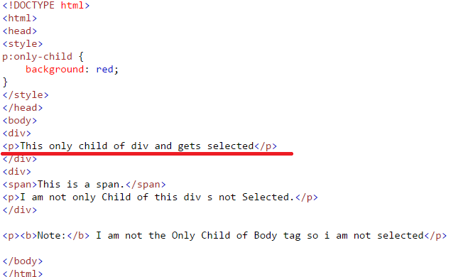

1. p:only-of-type🡺 later

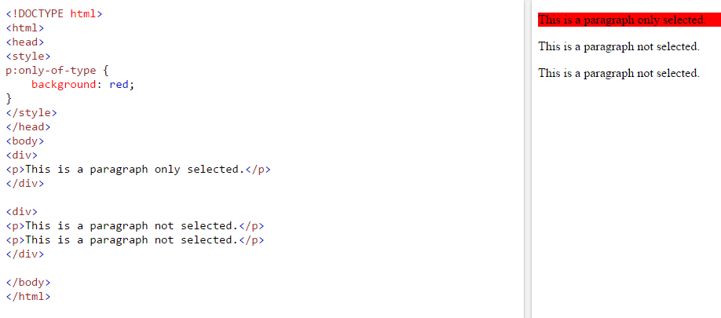

1. **input:optional**🡺 Selects input elements with no "required" attribute
2. **input:read-only**🡺 Selects input elements with the "readonly" attribute specified
3. **input:read-write**🡺 Selects input elements with the "readonly" attribute NOT specified
4. **input:required**🡺 Selects input elements with the "required" attribute specified
5. **:root**🡺 Selects the document's root element
6. **input: valid**🡺 Selects all input elements with a valid value.

Few Other Selectors:

1. p.intro🡺select <p>element which has the class= “intro”

🡺if the above selector selects more than one <p>element then its content is accessed via index , as shown below.

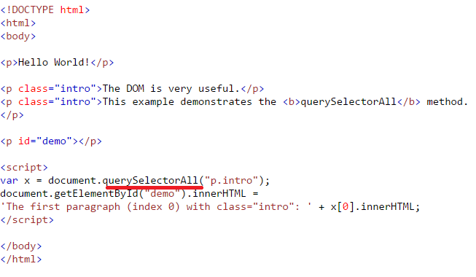

1. document.getElementById("myBtn").**addEventListener**("click", displayDate);